

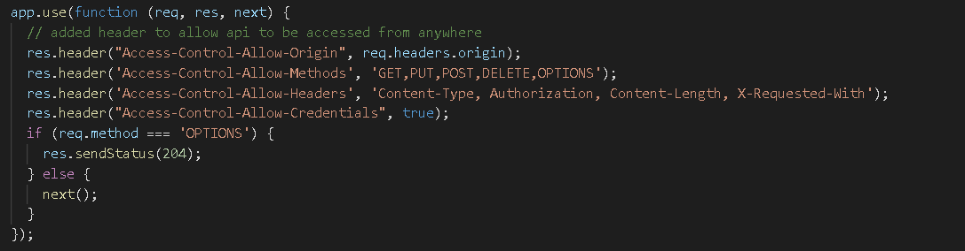

Res.sendFile –

Send home index file when user hit the root path



Ex - 

Res.download –

Download a file at client side

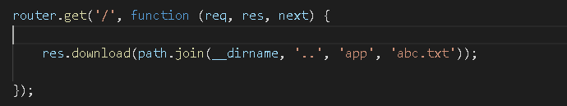

Ex - 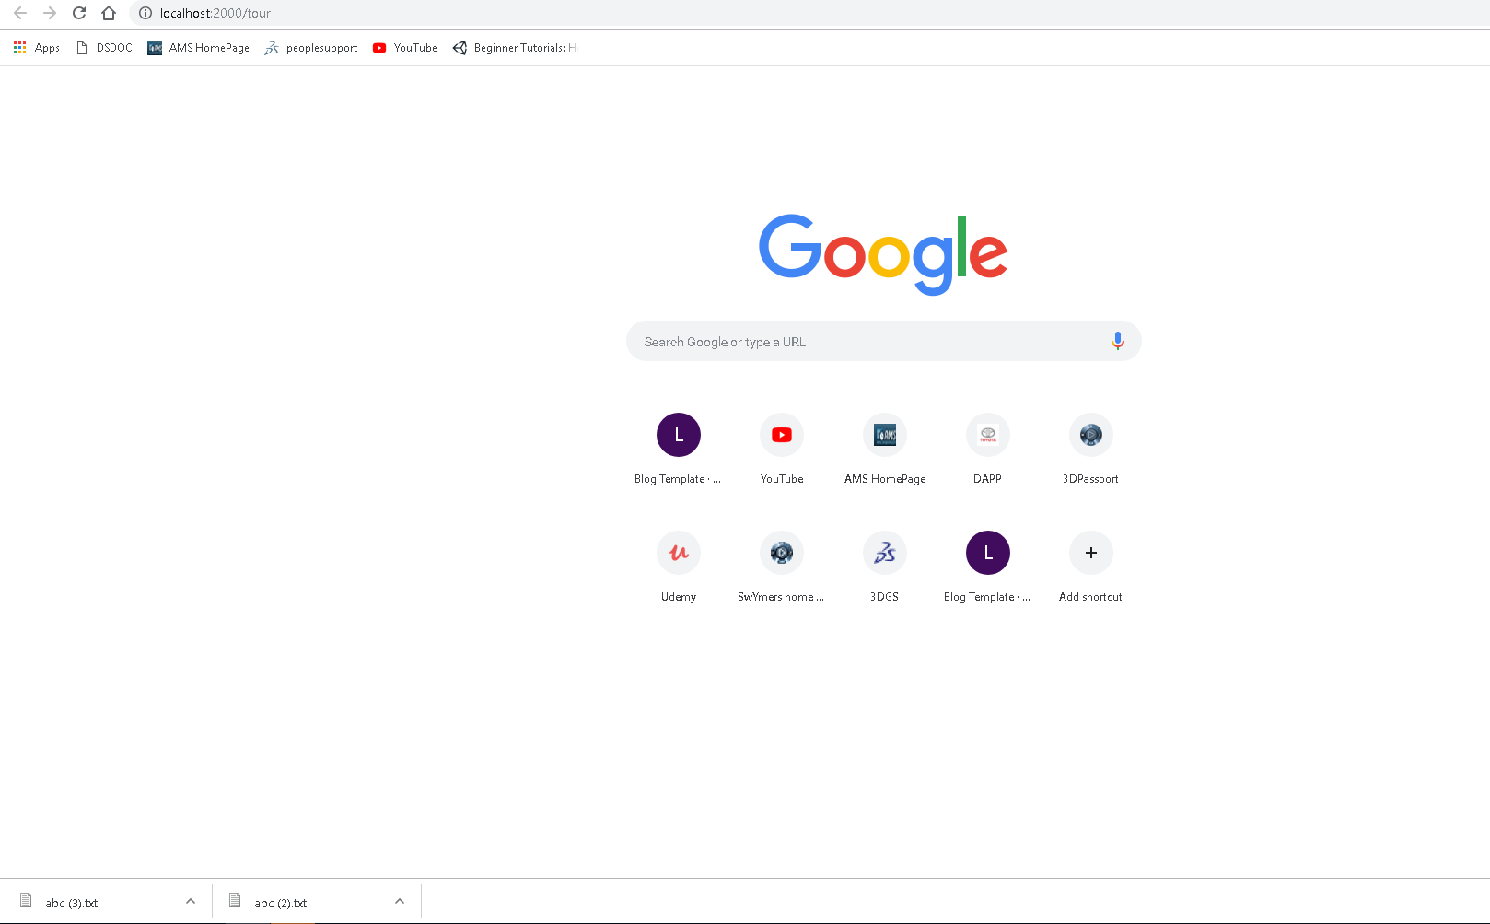

**Api’s -**

[**https://expressjs.com/en/api.html**](https://expressjs.com/en/api.html)

